SWOT Project Name:
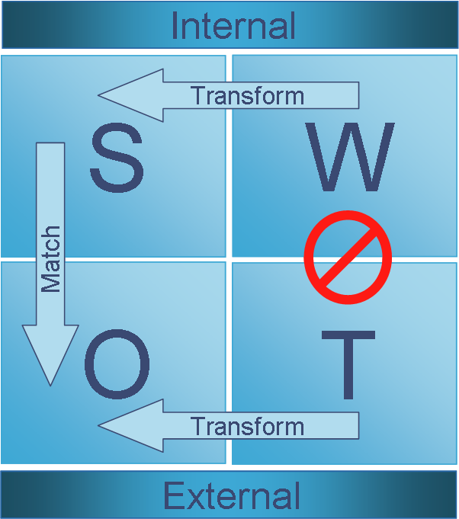
Analyze A Real Business
SWOT analysis is a tool for auditing an organization and its environment. It is the first stage of planning and helps marketers and managers to focus on key issues. SWOT stands for strengths, weaknesses, opportunities, and threats.

→ Strengths and weaknesses are internal factors.
→ Opportunities and threats are external factors.
- You will be creating a VISUAL representing a real-life business’ SWOT Analysis (choose from company list below)
- You will create your visual ALONE, however, you can choose a business that someone else is doing so that you can talk through the business’ SWOT
- Use the graphic organizers below to organize your information
- Print your final creation & hang up for a Gallery Walk
- Be prepared to comment on each other’s creation using sticky notes

Business Chosen:
Short Description:

Products & Services | Competitors
Discussion Points:
- What is your company’s key situation or issue

- What is your recommendation for future success?

SWOT Analysis Graphic Organizer
Find at least three instances of each category.
Strengths | Weaknesses
Opportunities | Threats

Grading Rubric  Your visual must include: | Student Score | Teacher Score
Images and graphics related to the company & topic | /5 Points | /5 Points
3 strengths (internal - found in the company) | /5 Points | /5 Points
3 weaknesses (internal - found in the company) | /5 Points | /5 Points
3 opportunities (external-found outside the company) | /5 Points | /5 Points
Three threats (external - found outside the company) | /5 Points | /5 Points
Graphic organizer is fully completed with the discussion points answered in complete sentences | /5 Points | /5 Points
Total Points | /30 Points | /30 Points
Adapted from Niki Kube, Business Educators Facebook group https://docs.google.com/document/d/1op15MeAXSI-eC42cgRbPLz6nAIVYInDmJ1kh55-rhiQ/edit?fbclid=IwAR19NEgvyFo8MOL27UHiI7ELUs_S94oga3eWN95o_bH4eLJMQeaTs1lIfSQ

List of Companies to Choose

Adidas
Amazon
Apple
BMW
Chipotle
Coca-Cola
Costco
Disney
Facebook
FedEx
Ford
Google
Home Depot
Johnson & Johnson
McDonald’s
Microsoft
Nestle
Netflix
Nike
Nintendo
Nordstrom
Pepsi
Samsung
Southwest Airlines
Starbucks
Target
Tesla
Twitter
Uber
Under Armour
Volkswagen
Walmart
Whole Foods

